### misc

# The E-Newsletter

A Joint Project of Talkeetna Public Library and its Friends

April 2021 Vol. 10 No. 4

**FROM THE LIBRARY**

The library is so proud of our staff. They have worked so well together this past year, striving to provide the best service to our patrons and communities. It has been hard at times to be unable to offer inhouse programs, meetings, and celebrations. But thanks to ingenuity, hard work and Zoom, Talkeetna Library is moving forward with indoor and outdoor programming. Look for the start of a community garden, disc golf course and an upgrade to the Literary Trail this spring and summer. Our goal is to get as close to normal as possible. The staff welcomes volunteers and is open to suggestions.

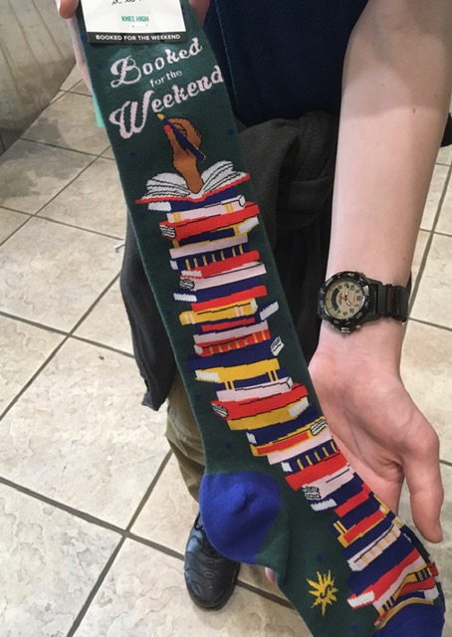

**CONGRATULATIONS TO TASJA WILLIAMS!**



The Talkeetna Library is proud to announce that Tasja Williams has been selected to join in the Association for Rural and Small Libraries Outstanding in Their Field Leadership Institute. She was one of 30 library professionals from around the world chosen to engage in residential, online and conference experiences. The 18-month program begins this August and will deepen their understanding of and commitment to professional values while gaining practical managerial skills.

Key priorities for this institute are to develop strong rural and small library leaders, and give them tools to strengthen the communities they serve.

This program is funded by a grant from the Institute for Museum and Library Science.

**We are so proud of Tasja!**

**And we welcome our newest on-call staff member, Tristan Williams. We are so happy he has joined us.**

**COMING SOON!**

**BOOK SPINE POETRY**

The Friends of the Talkeetna Library are sponsoring Book Spine Poetry contest in April to celebratePoetry Month.

To participate, choose no more than 5 titles, arrange them to create a poem. Take a photo of the stack and submit it to the library.

Due date for submission is April 21st. Voting for best poems will run from April 22nd through the 28th. Winners will be announced April 30th

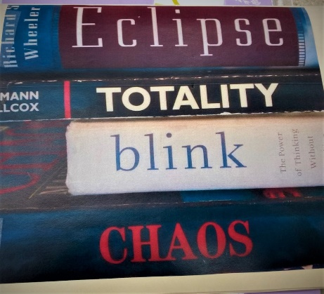

**SEED CATALOG**

The Seed Catalog is back! Small packages of seeds will be available for you to start your gardens. Each packet will include directions for planting.

Donations of seeds are welcome.

**DROP EVERYTHING**

**AND READ**

April 12th is National Drop Everything and Read Day!

The Talkeetna Library invites you to pledge to read 30 minutes on Monday, April 12th. You can read by yourself or with a family member or friend.

The library encourages our community to read, and then to send a picture to the library for display on the bulletin board. There will be awards in many categories!

For more information, you can contact the library at 861-7645

**STRONG WOMEN (AND MEN) VIA ZOOM**

The Strong Women Strength Training Program is aimed at women (and men) 40 and older who wish to improve their strength, flexibility and balance. The group meets twice a week for 45 minutes.

The Library continues to offer Strong Women virtually through ZOOM. The meeting ID: 921 4648 1028.You will need a passcode to join. Please call the library for it.

Weights and handouts are available at the library. There is no charge for this program.

Please join in a few minutes early for a pre-workout chat.

**STORYTIME**

**THURSDAYS 11:15am**

**VIA ZOOM**

**Storytime for all ages is held every Thursday at 11:15. It will continue on Zoom, with outdoor activities beginning as soon as the snow is gone.**

**April 1: Peepmobiles!**

**April 8: Elephants Roar!**

**April 15: Seeds and Seedlings**

**April 22: Earth Day Crafts**

**April 29: Science Thursday**

**Grab and Go bags with crafts and snacks are available on Tuesdays after 2pm through Saturday at closing.**

**The meeting ID and passcode are available at the library.**

You may call the library at (907) 861-7645 for further information or visit the library’s [Facebook page](https://www.facebook.com/pages/Talkeetna-Public-Library/114131178605007).

**BREAKFAST BOOK CLUB VIA ZOOM**

The Breakfast Book Club meets Tuesday, April 20th, at 11:15am via Zoom. The selection for the month of April is The Unlikely Adventures of the Shergill Sisters by Balli Kaur Jaswal.

Decisions on summer meetings will be made at the April Meeting.

Copies of the book are available at the library. Stay tuned for the Zoom number and password. Or call the library at 861-7645 for more information.

**BOOK 2 MOVIE TEEN PROGRAM**

The Book 2 Movie Teen Program has ended for this season. Look for its return in the fall with new books and movies to discuss and enjoy.

**PAGE TO SCREEN TWEENS PROGRAM**

The April selection for the Page to Screen Tween Program is Fantastic Mr. Fox by Roald Dahl.

Grab Bag with books and snacks will be ready for pickup at the desk. The movie version will be reserved during April for the use of enrollees.

**FRIENDS OF THE**

**TALKEETNA LIBRARY**

The Friends of the Talkeetna Library meets the 1st Friday of every month on Zoom for the time being at 1:00pm.

New members are always welcome. We would love to see you at the meeting,

**FYI**

Notary services, trailhead and remote parking passes, and IRS forms are available at the library during normal hours.

WIFI is available 24/7 from the parking lot. ,MSBPublic with password MSBfree!

Library updates are on FACEBOOK and KTNA

**Friends of the Talkeetna Library can be found on Facebook or www.friendsofthetalkeetnalibrary.org**